Year 12

Physical Education Studies

Sports Psychology

|  |  |  |  |  |  |  |
| --- | --- | --- | --- | --- | --- | --- |
|  | Performance Routine | Imagery | Relaxation | Self-Talk (Positive) | Self-Talk (Negative) | Goal Setting |
| Arousal | Increase or decrease | Increase or decrease | Decrease | Increase | Decrease | Increase or decrease (if goal is not met) |
| Stress | Decreases | Increases or Decreases | Decreases | Decreases | Increases | Increase or decrease (if goal is not met) |
| Motivation | Increase | Increase | Decrease | Increase | Decrease | Increase or decrease (if goal is not met) |
| Concentration | Increases | Increases | Increases or decreases | Increase | Decrease | Increase or decrease (if goal is not met) |
| Self-Confidence | Increase | Increase | Increase | Increases | Decreases | Increase or decrease (if goal is not met) |

**GRIPS** and **SMACS**

Goal Setting:

Specific

Challenging

Controllable

Attainable

Measurable

Personal

Group Cohesion relates to how well a group works together and stays together.

* Based on two things
  + Task cohesion
    - How many teammates are on the same wavelength in terms of what they want to achieve. Eg. A championship vs for fun
  + Social cohesion
    - How well the teammates get along and the degree to which team members enjoy being together
* Task and social cohesion are independent of each other

Measuring cohesiveness

1. Sociograms
2. Questionnaires
3. Observation

Carron’s Model

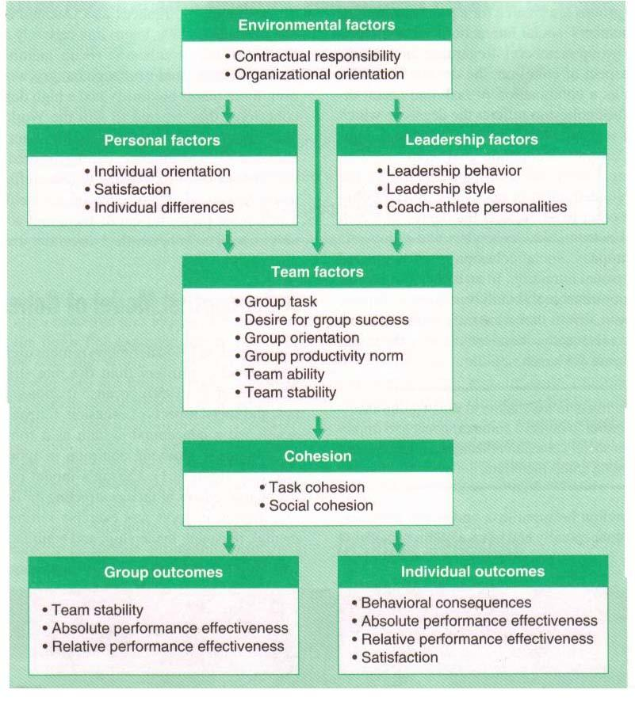

1. Environmental factors
   1. Contracts
   2. Family/Significant other expectations
   3. Age
   4. Geographical limitations
   5. Group size
2. Personal factors
   1. Task Motivation = leads to task cohesion
   2. Affiliation motivation = leads to social cohesion
   3. Self-motivation
   4. Individual satisfaction
      1. Attitudes
      2. Goals
      3. Level of commitment
      4. Expectations
3. Leadership factors
   1. Most appropriate style of leadership must be used
   2. Good leaders will
      1. Set team goals
      2. Individual roles
      3. Team rules
      4. Standards of behaviour
   3. Leaders must be consistent with their players and have clear communication
   4. Compatibility between players and leaders essential in team cohesion
4. Team factors
   1. Team stability
   2. Length of time team has been together
   3. Prior success/failure
   4. Team goals
   5. Type of sport (team or individual)
   6. Team norms for productivity
   7. 3 levels of communication/interaction
      1. Co-acting

* Working together as a team but no communication between members
* Scores are dependent on individual scores
* Eg. Golf, darts
  + 1. Interacting
* Requires a high level of communication
* Eg. ball games such as basketball which require a high level of communication and interaction so that optimum performance is to be achieved
  + 1. Mixed
* Combination between co-acting and interacting activities
* Eg. cricket

Other factors impacting Cohesion

1. Common Values
2. Group Identity
3. Goals
4. Roles

Task cohesion is developed by:

* Clear and regular communication
* Clear and understood expectations/norms
* Clear individual roles for each player
* Pride within subunits – defence, midfield, offence
* Challenging by realistic goals for both team and players
* Fair and consistent with the group = equal treatment
* Prioritise team goals over individual goals
* Promote high levels of motivation
* Regular team meetings

Social cohesion is developed by:

* Social interaction away from the sport
* Open and honest communication
* Resolve conflicts quickly
* Team building exercises
* Establish team standards of presentation
* Trust and respect within the group
* Informal roles within the group

Barriers to group cohesion

* Personality clashes
* Unclear/conflicting roles
* Frequent changes to the group
* Disagreement on group objectives
* Power struggle between players

Benefits of Cohesion

* Extensive communication and motivation within the group
* Increased feeling of the group as a whole
* Players work together to achieve team goals ahead of personal goals
* Players enjoy others success
* More successful in achieving their goal
* Members in groups that are cohesive are more satisfied with that group and are willing to stay in the group longer

Social loafing (Ringlemann Effect)

* The tendency of individuals to lessen their effort when they are part of a group – the larger the group, the greater the chance of social loafing

Why does loafing occur?

* Individual athlete sees that other athletes aren’t working hard giving him the impression that he doesn’t have to work hard
* Belief that their efforts wont make a difference to the team and little to any effect on the outcome
* Easier to hide in a pack (avoiding hard work)
* Belief that their efforts are not essential to achieving the goal

Impact of Social Loafing on Individual and Team Performance

* Social loafing causes individual and team performance to be below optimal
* Individual effort increases where each player’s input is identifiable
  + Leads to an increase in individual and team performance

Minimising Social Loafing

1. Write a team contract which states
2. Develop rules of conduct
3. Create appropriate group sizes
4. Evaluate all members of a group individually = members individually accounted for